NPM ASSIGNMENT

- UPDATE COMMAND - sudo apt update
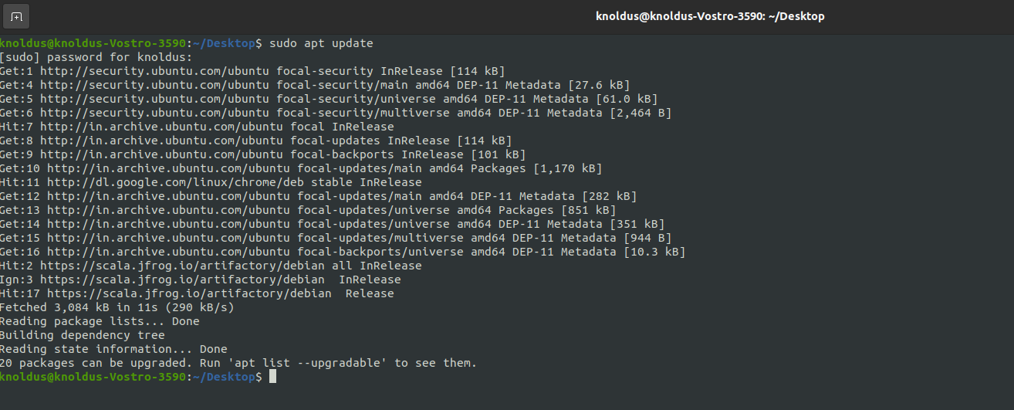

- INSTALL NODEJS COMMAND-
sudo apt install nodejs
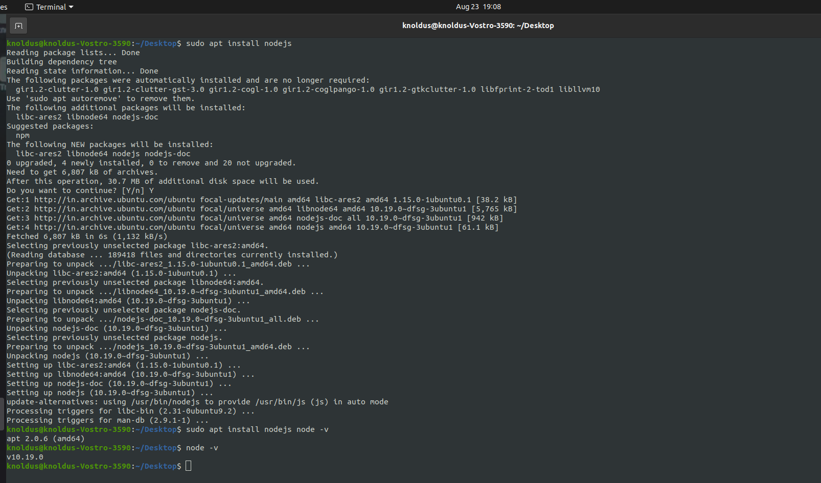
- NODEJS CLI COMMAND- node -v
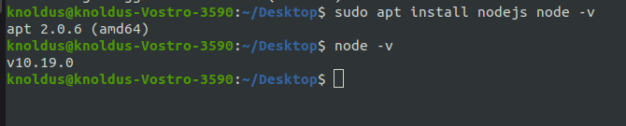

- INSTALL NPM COMMAND- sudo apt install npm

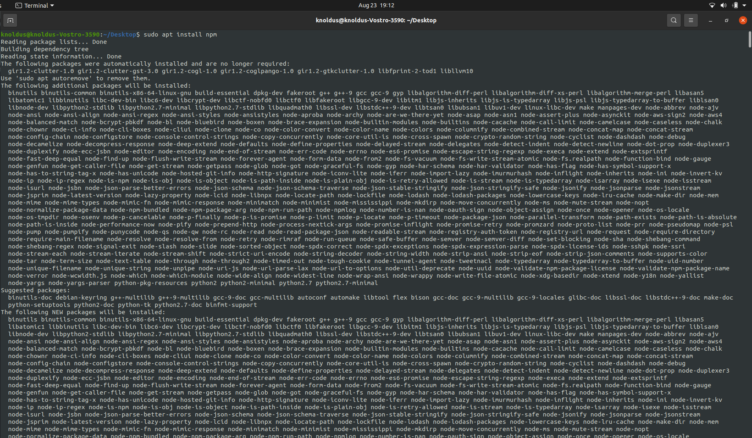

- INSTALL ANGULAR COMMAND-
sudo npm install -g @angular/cli

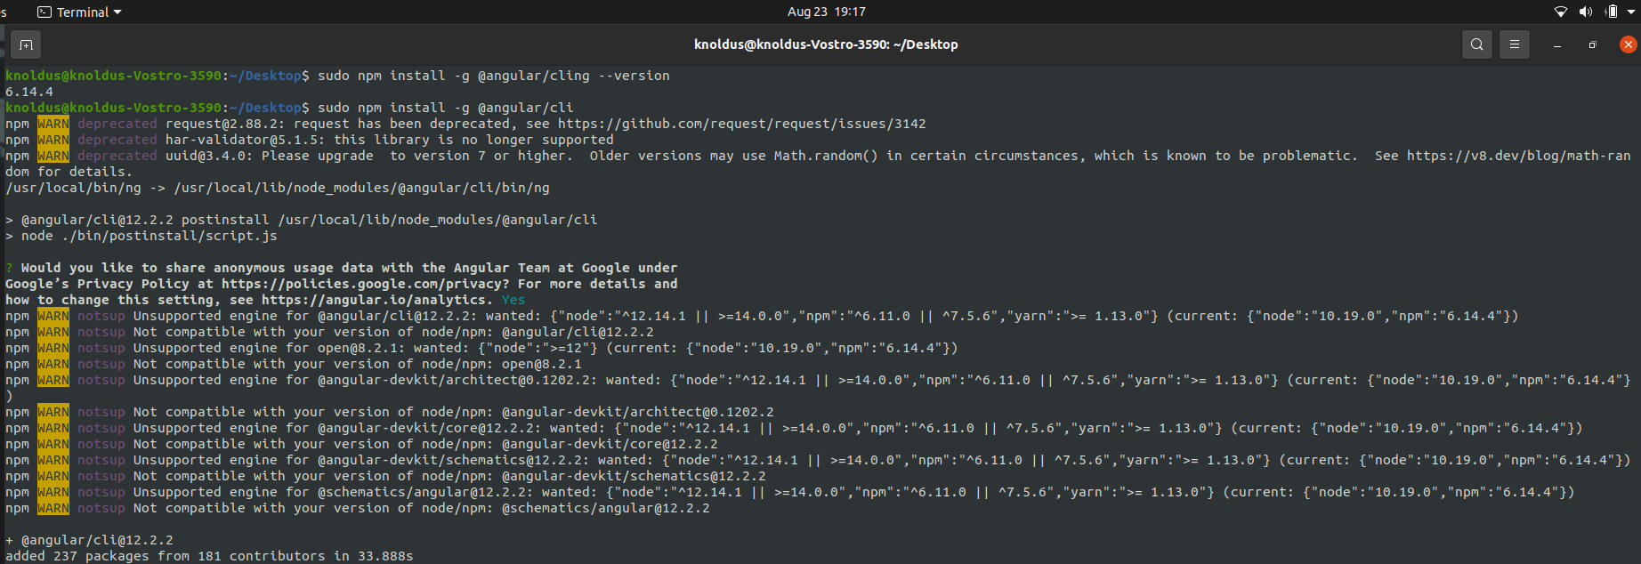

- ANGULAR CLI COMMAND- ng –version

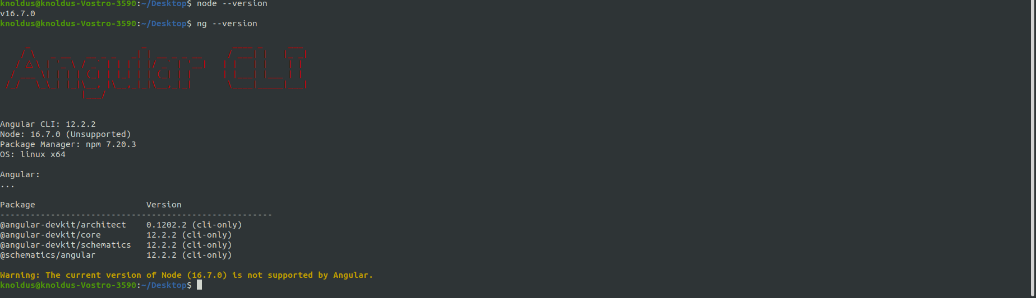

- COMMAND FOR ANGULAR CLI LATEST VERSION –
Sudo npm cache clean –f
Sudo npm install –g n
Sudo n latest

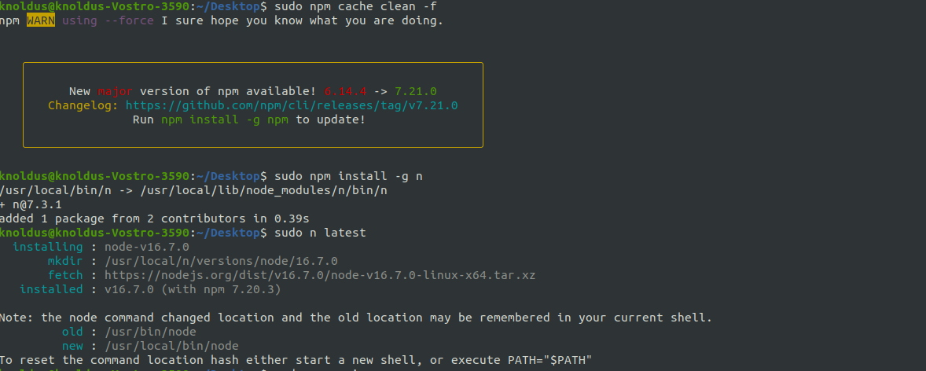

- IONIC INSTALL COMMAND-
sudo npm i -g @ionic/cli

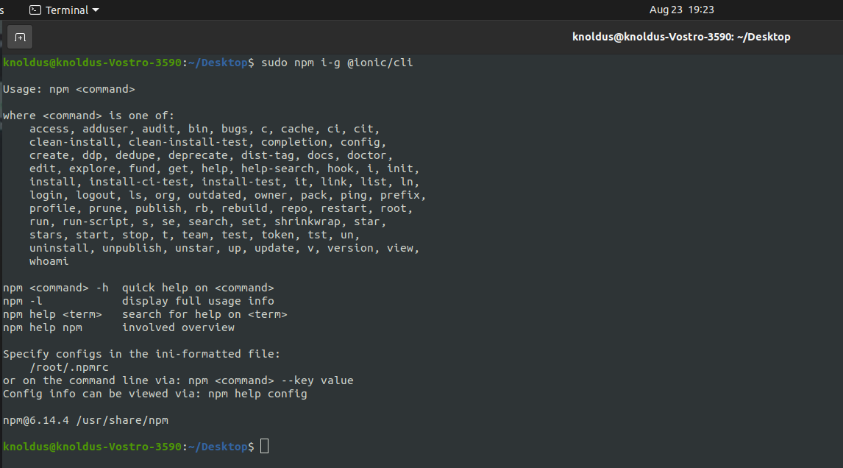

- IONIC CLI COMMAND-
ionic –v

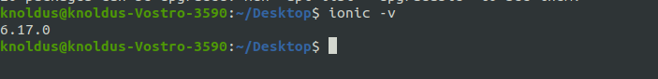

- INSTALL VUE COMMAND-
sudo npm install -g @vue/cli

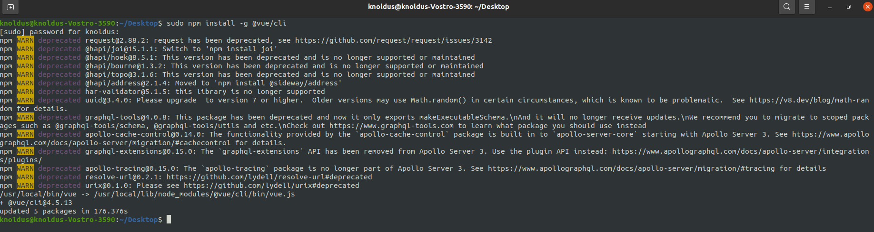

- VUE CLI COMMAND- vue --version

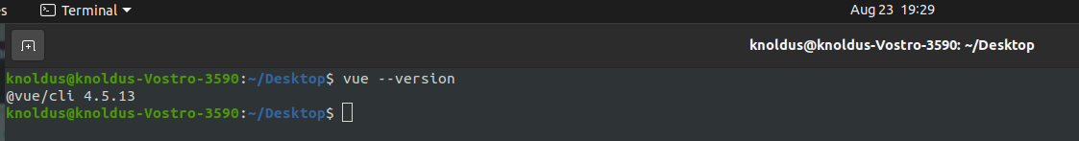

- INSTALL CREATE REACT COMMAND-
sudo npm -g install create-react-app

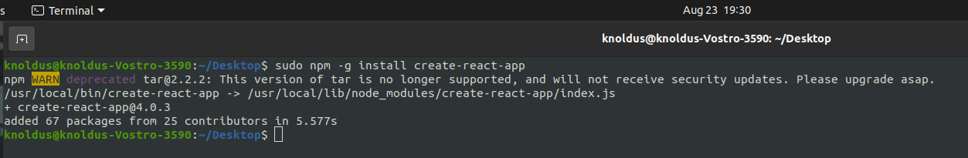

- CREATE REACT CLI COMMAND-
create-react-app --version

